**Applicazioni per dispositivi mobili**

**course**

**a.y. 2017/2018**



**UniEvent**

**Design documentation[1],[2]**

|  |  |  |
| --- | --- | --- |
| **Team Members[3]** | | |
| **Name** | **Student Number** | **E-mail address** |
| **Davide Micarelli** | *236829* | davide.micarelli@student.univaq.it |
| **Tony D’Angelo** | *236027* | *tony.dangelo@student.univaq.it* |
| **Massimo Nardecchia** | *227829* | [massimo.nardecchia@student.univaq.it](mailto:massimo.nardecchia@student.univaq.it) |
| **Antonello Micarelli** | *228405* | *antonello.micarelli@student.univaq.it* |

Strategy

# Product Overview

App made by student for the student

Platform for creation, organization and promote events all around the world, especially for the university student (party and cultural events) with the possibility to take a ride.

We have a strong social integration with Facebook Twitter etc., everyone can create an event and other people can visualize them and filter the list for their interests.

# Competitors

Principal competitors are:

1. Eventbrite
2. Nearify

The first one doesn’t allow you to create event in the app, you need to use another application, the interface is graphically poor, you can’t follow your friend interest ad event, all things that our app can do, these are the main difference.

Nearify has many points to blame. In first place during our test it didn’t work even if tested on different smartphone, it has many bugs.

The interface is really nice, it offers many features like favorites, sharing events with friends, but it doesn’t permit the creation of new event, only visualize them and filter by date and place.

Our app is mainly focused on students, not generals events.

# User Research

The needs that we want to satisfy are:

* Group of friend that want to find something interesting in their city, not only party, but also cultural event, like museum, cinema, promotion.
* Pub, museum, cinema, locals that want to promote their event with low cost (without print any manifest for example) and monitoring the event.

The main goals are:

* Provide easy and intuitive interface for the users that can search, create and organize events.
* Provide system for going to the events with other people.

# Personas





Scope

**Features**

* **Profiling**
* **Events creation by users**
* **Events search and visualization by users (filter also)**
* **Events booking (only for limited numbers events)**
* **Notification System**
* **Social integration**
* **Save favorites events**
* **Sharing with friends (social sharing)**
* **Searching place with gps or manual**
* **Events management**
* **Event feedback at the end of it**

**Scenarios**

It is a short, simple narrative describing how a persona might go about trying to fulfill one of those user needs. By imagining the process our users might go through, we can come up with potential requirements to help meet their needs.

**Story:** *This story start in a cold lonely evening, our protagonist, Gino, those weekend remains in the study’s city and he really want to go out with friends for relaxing.*

*But…there is a problem, he don’t know much of the city or any events…but he’s also listen about a new app, very useful, used by a lot of his comrades, he’s go to the app store and find unievent, once installed the app without any registration Gino enter to the list event, with gps the app localize them and list all the event in his city, in that day.*

*Very excited for the function he decides to register with google plus and to have access to full voice in the menu.*

*After found an interesting event in his town after filter the list, ask a passing by car through the app and booking the event paying with paypal.*

*The day after he leaves a good feedback to the event.*

Structure

# Navigation model

Navigation model of your app.

Description of its main parts and the relevant choices you made. For each view and for each main navigation flow you have to describe your design decisions and their main objectives.

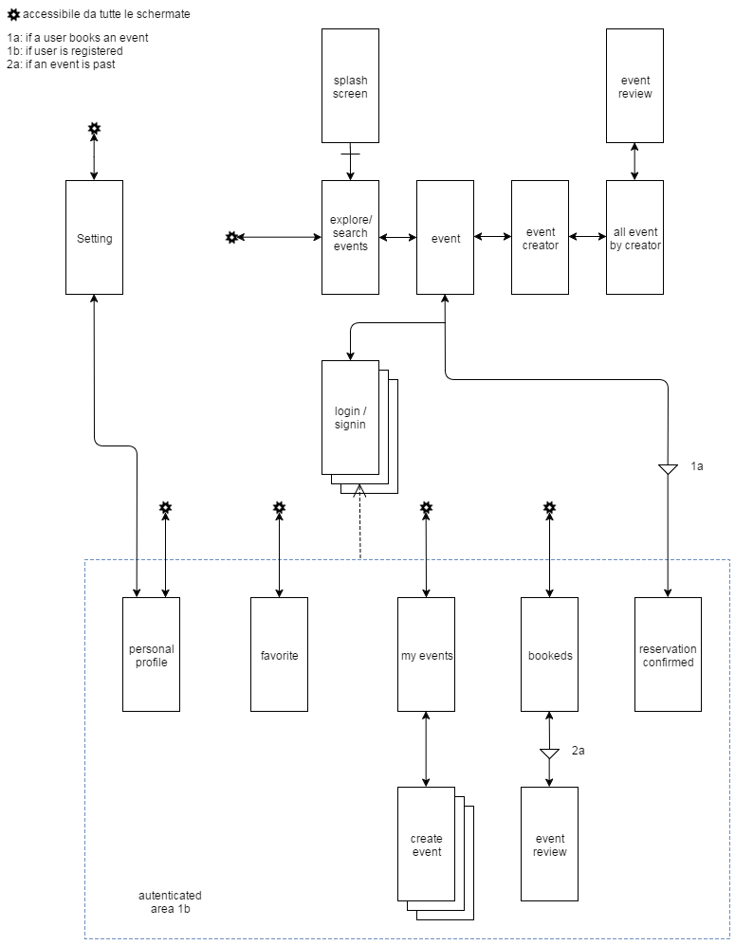

# Decision ad flow:

* All the elements with the symbol  are part of menu, many of the voice are accessible only with registration
* For making our app easier to use and pleasing the users proceed to registration only after entering in restricted area, and without obligation, naturally the unregistered users can only view events. For other functionality is required login/registration.
* We choose to start with splash page and after the loading the search event, the app asking authorization for gps functionality and set the city, if it doesn’t happen the user can set city manually
* We choose to put setting in the profile option for making more clear the ux, and it’s accessible for everyone
* When an event end it’s possible to review them and give an evaluation

# Data

Provide a class diagram representing all the contents you manage in your app. As a reference for class diagrams, use this: <http://it.wikipedia.org/wiki/Class_diagram>

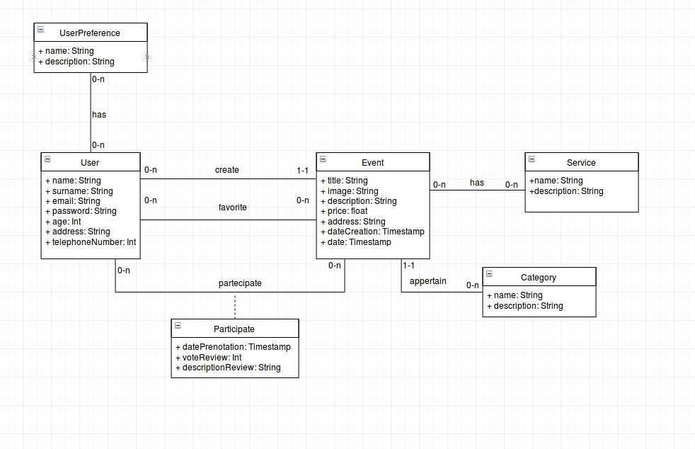

Skeleton

Lo-Fi Wireframes of your app. In this phase you have to create a **complete wireframe** representing all the views described in the navigation model.

Description of the relevant choices you made about the user interaction and how information flows among views.

The mainly choices are:

**Use of cards**, for encapsulate all information linked to the event in one box

**NAVIGATION DRAWER**

When there is insufficient space to support tabs, side navigation is a good alternative. Side navigation can display many navigation targets at once. A drawer remains hidden until invoked by the user.

Apps with a single “home” should list the most frequently accessed destinations at the top of side navigation.

Side navigation may appear either with or without a navigation drawer.

Recommended for:

* Apps with many top-level views
* Enabling quick navigation between unrelated views
* Deep navigation structures
* Reducing visibility of infrequent destinations

**Expandable search**

Use expandable search when search is not the primary focus of your app.

Display a magnifying glass icon in the toolbar instead of a search text box.

Touching the search icon causes the toolbar to transform, clearing other content and displaying a search text field. If voice search is supported, the microphone icon also appears.

The search text field automatically receives focus, and, if needed, the onscreen keyboard will appear. Historical search suggestions can be shown beneath the toolbar. Choosing any of the suggestions submits the query.

Touching the up arrow closes search and restores the original presentation of the toolbar.

**Splash page**

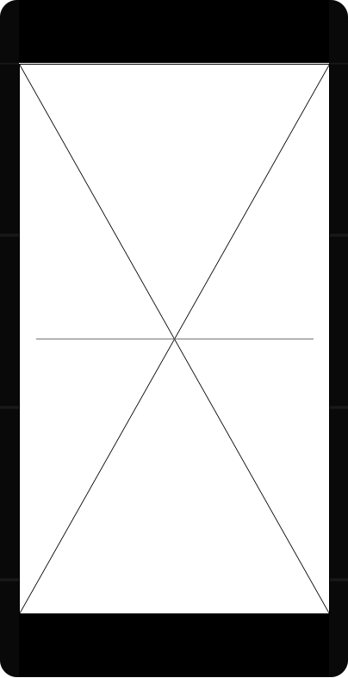The splash screen of the app, we have the logo of the app with a bar of loading and color palette that we decided in the hi-fi.

**Explore/search**

**Description:** In this screen we have the search and a list of events, every event show a few information about itself, like title price(optional) and date and favorite button on the manifest of event.

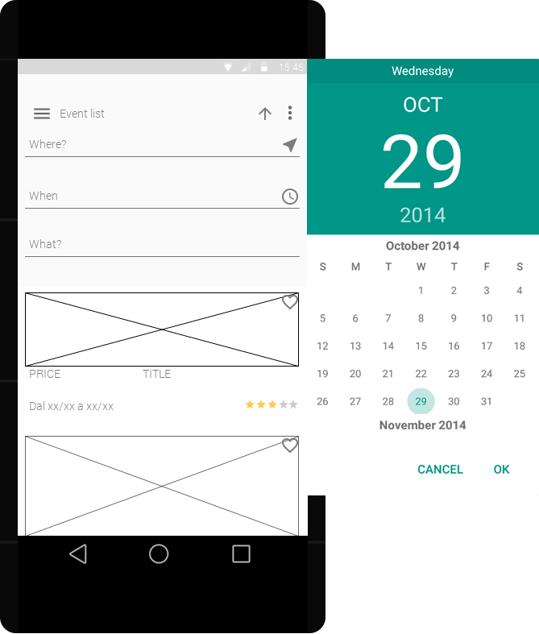

The search it’s expandable type and have 3 input type, **where** with the possibility of geolocation, **when** with a calendar integrated and a field **what** where you can insert key words or categories.

**Design pattern:** Rhythm pattern

**Navigation Type:** Cards

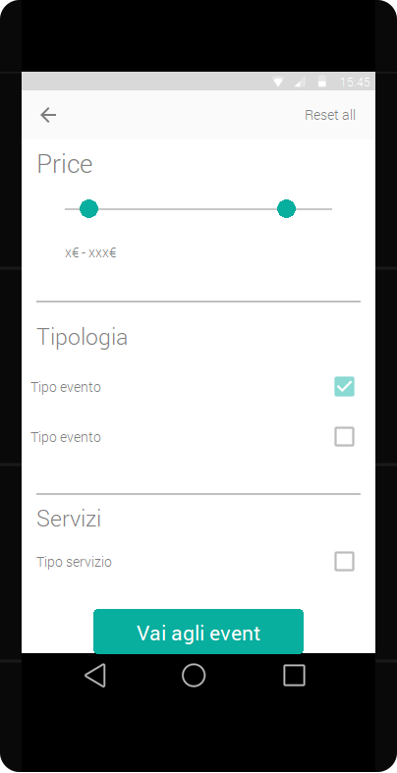

**Event page**

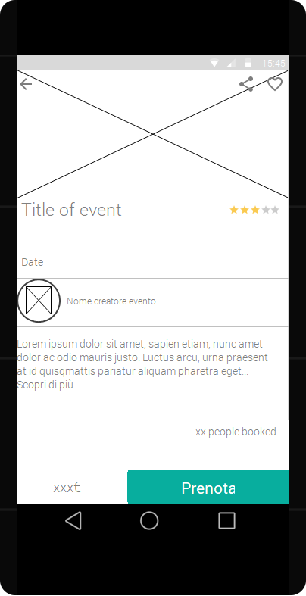**Description:** Descripting page of an event with manifest at top of page, title of event, date, on the footer in fixed position prenote button and price(optional), in the body we have a description, and the author

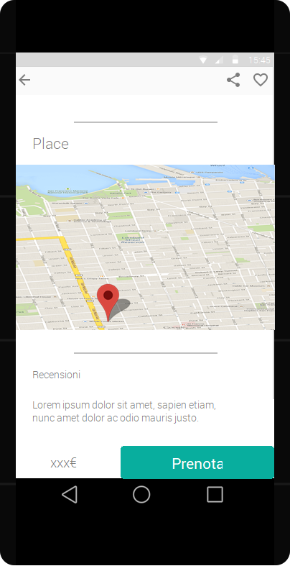

**Design pattern:** Hierarchy

**Navigation Type:** Image carousel

**Event creator**

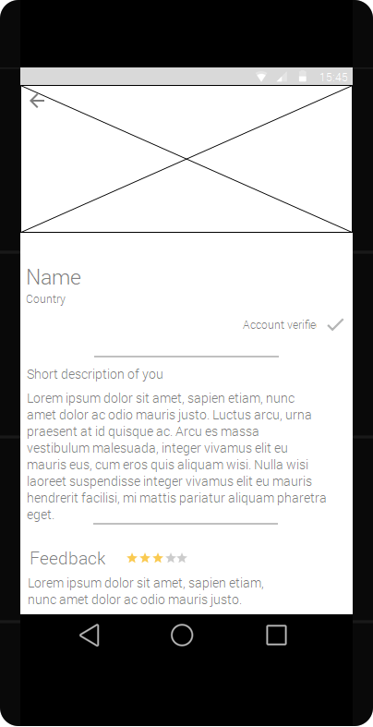**Description:** Descripting page of an event creator, with photo, name, his description, and the feedback of other users, the reviews of the user is made by a average of event feed.

In the end page a list of old events (in grey color) by this creators, and a button to return to the top

**Design pattern:** Hierarchy

**Navigation Type:** Image carousel

**Login/singin**

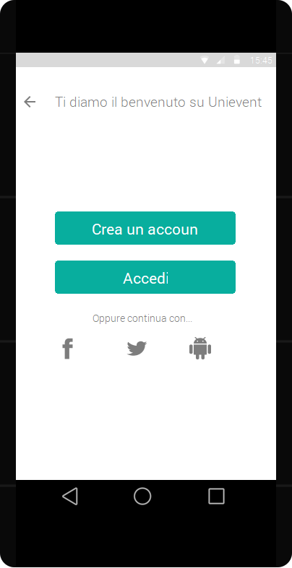

**Description:** Ultra short, in a single page registration, with possibility of login via facebook, twitter ecc. ecc.

**Forms:** Signin/Registration

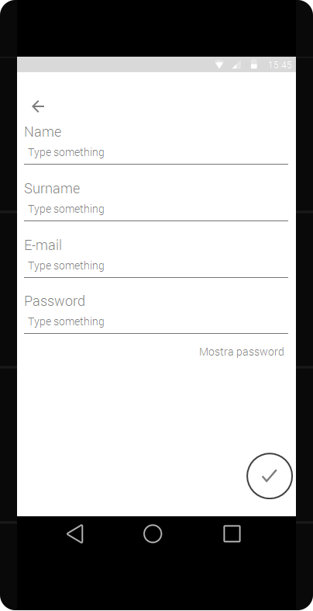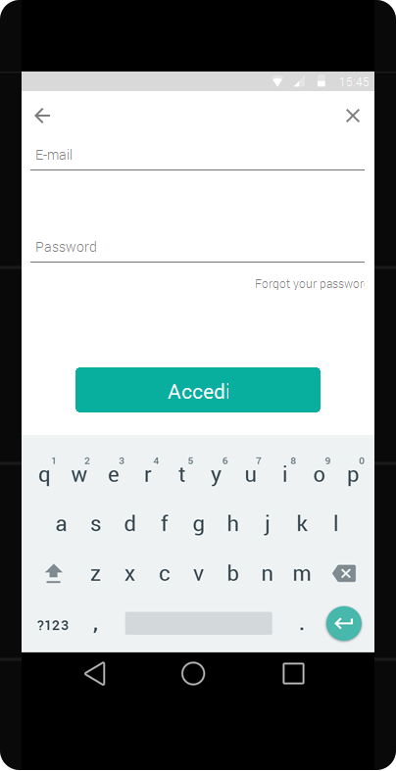

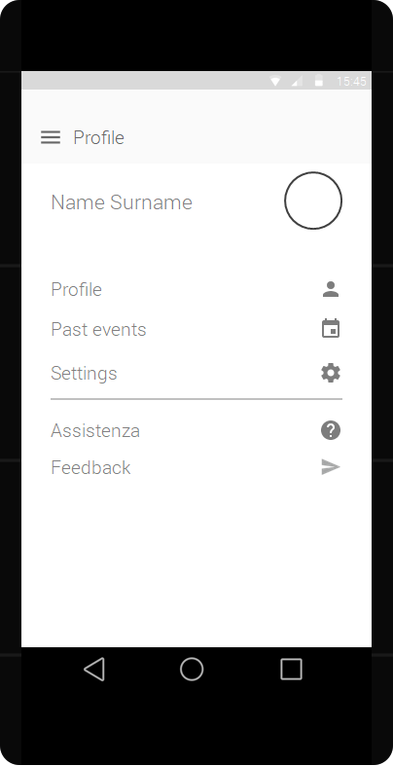

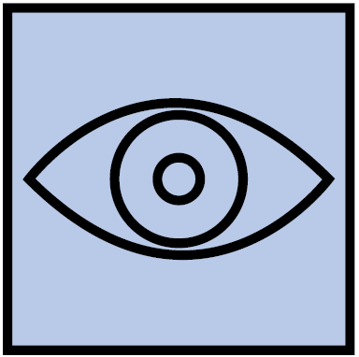Surface

Provide an Hi-Fi Wireframes of a **single view** of your app. Please choose a representative view to show here.

Description of the relevant choices you made about the layout and color palette, fonts, icons, etc.

The material color palette are this

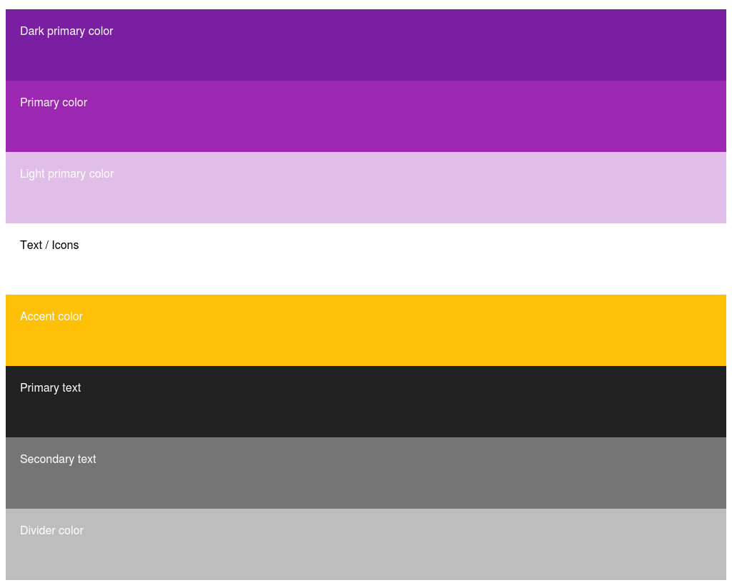

we choose complementary color violet/amber for light and more beautiful interface

**Font**: Comfortaa is a rounded geometric sans-serif type design intended for large sizes.

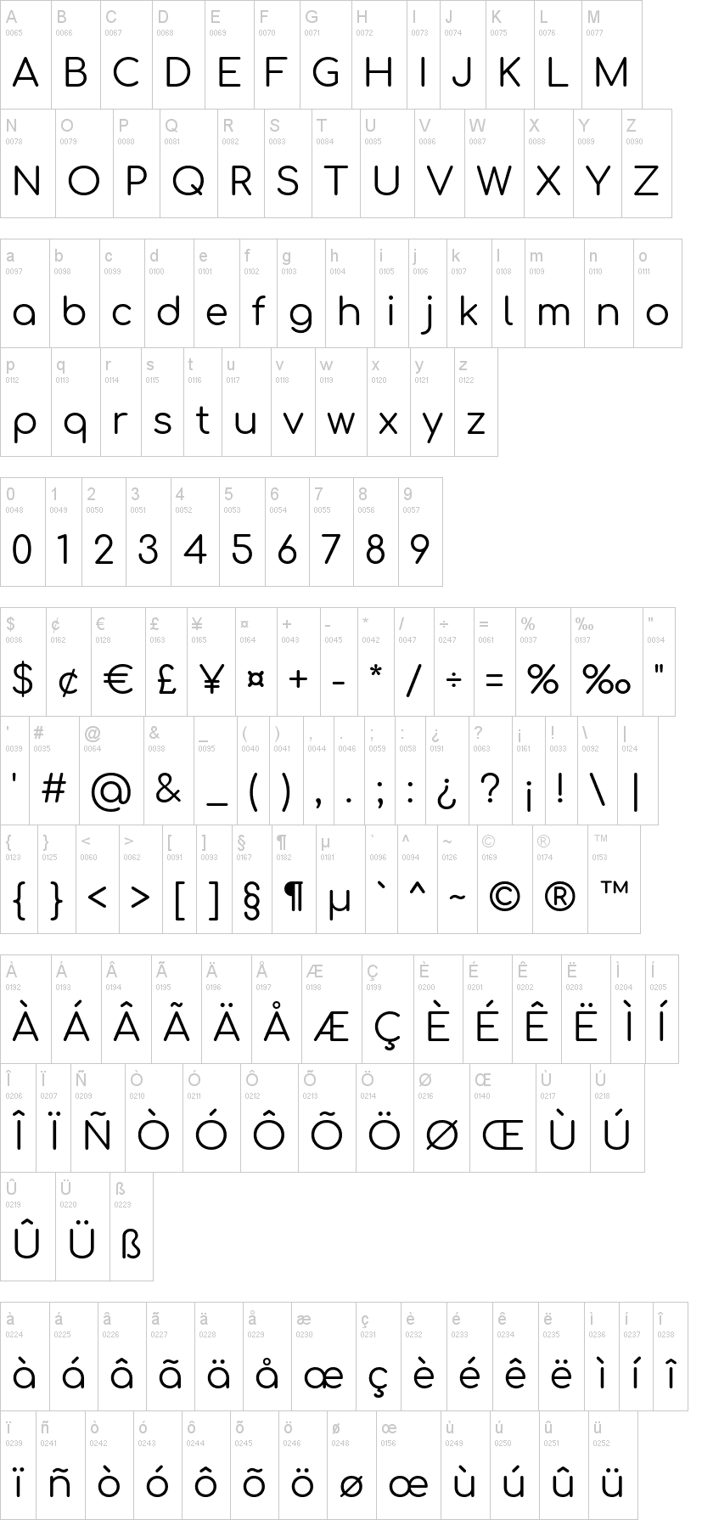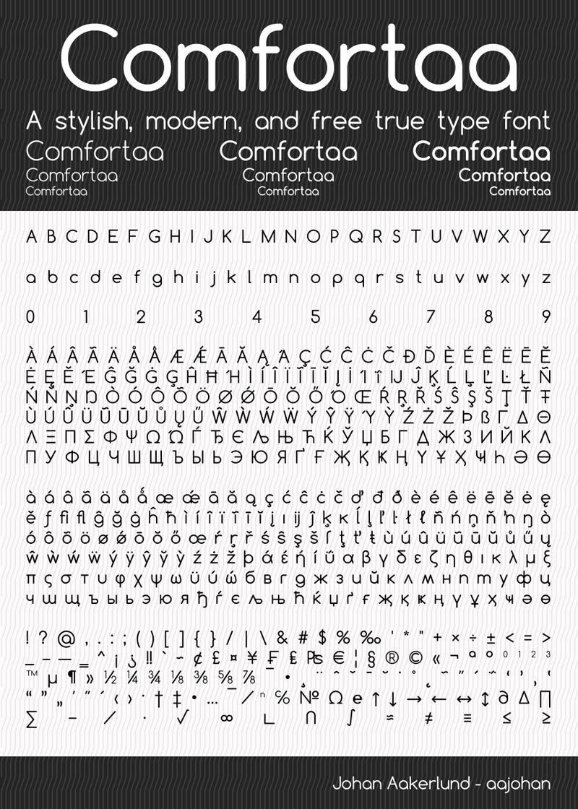

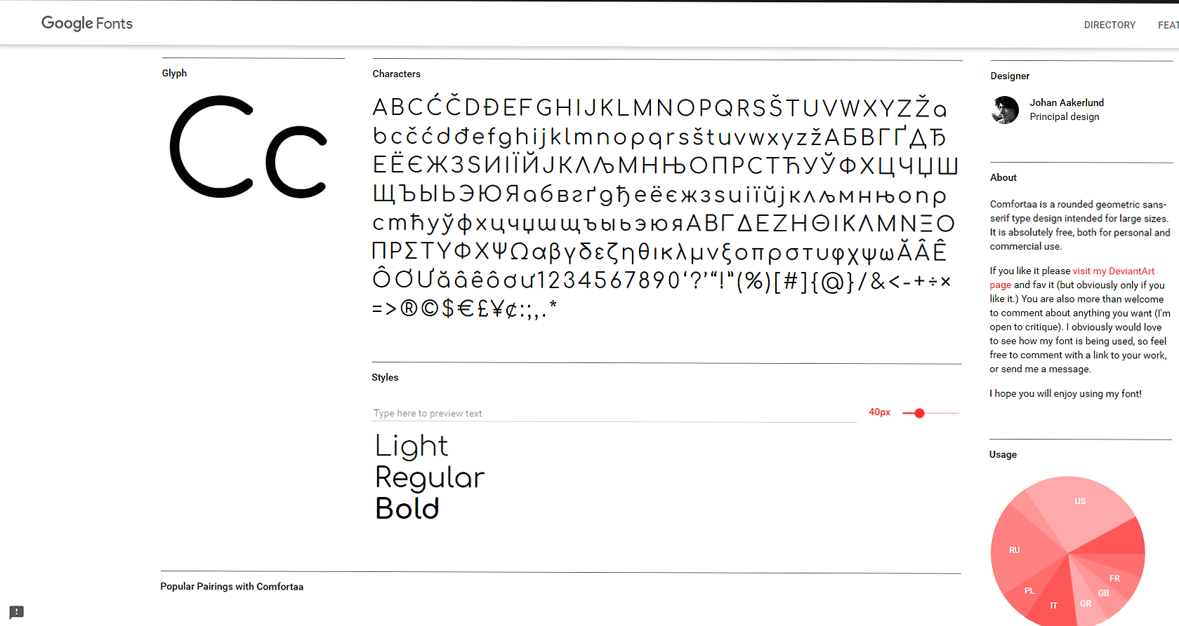

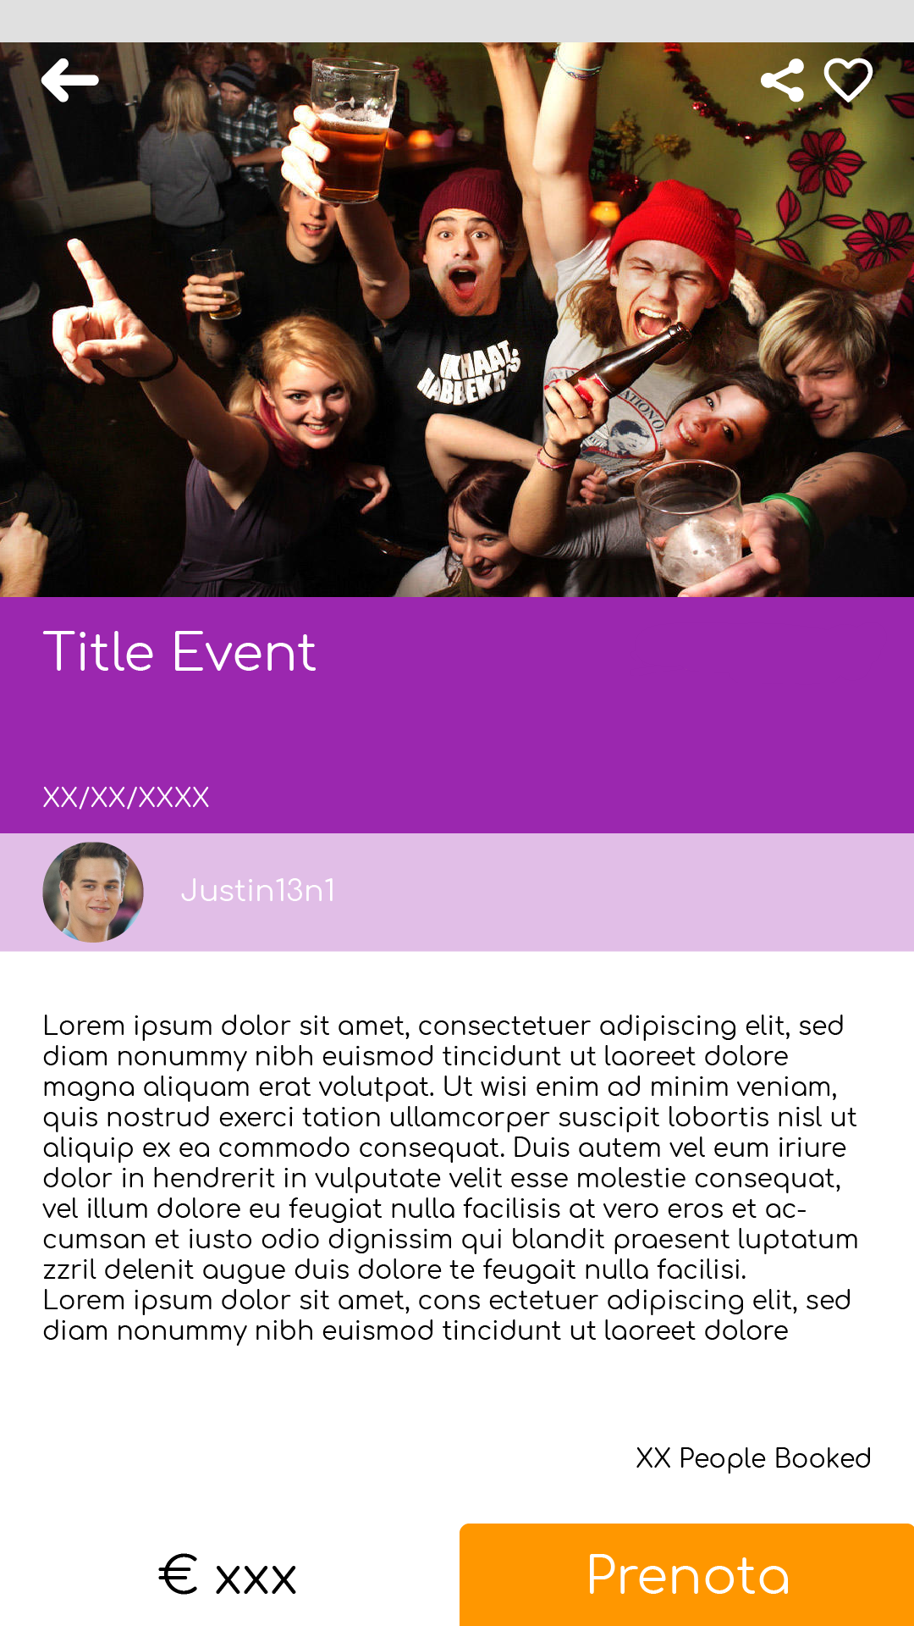

1. The max length of this document is 20 pages
2. The structure of this document is fixed, it cannot be changed in any way
3. The team leader is listed as first member in this table